**Online Shop**

1. **Import and use** the database **using SQL query.**
2. Display **transaction_id, customer_name, customer_gender**, and **transaction_date** for every **transaction that is done in 2021**.

(**SELECT, JOIN, YEAR**)

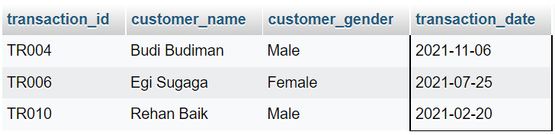

1. Display **transaction_id**, **Date of Transaction** (obtained from **transaction_date** in Month, dd YYYY format ex: November, 04 2022), **customer_name**, **product_name**, and **Total Price** (obtained from **product_price multiplied by quantity**).

**(SELECT, JOIN, DATE_FORMAT)**

1. Display **Name of Product** (obtained from **product_name** in lowercase format), **Product Price** (obtained from **product_price**), **Product Discount**(obtained from (random number from 0-30 then floor it and add '%' in the end, add 'Discount ' in the beginning)) for every **product name that starts with “Laptop”**. Then, combine it with **Name of Product** (obtained from **product_name** in lowercase format), **Product Price** (obtained from **product_price**), **Product Discount** (obtained from (random number from 0-30 then floor it and add '%' in the end, add 'Discount ' in the beginning)) for every **product price that is more than 2,000,000.**

**(SELECT, LOWER, AS, CONCAT, UNION, LIKE)**

1. Display **ID** (obtained from **staff_id**), **Name** (obtained from **staff_name**), **Gender** (obtained from **staff_gender**) for **staff_id ST001, ST002, ST003**. Then, combine it with **ID** (obtained from **customer_id**), **Name** (obtained from **customer_name**), **Gender** (obtained from **customer_gender**) for **customer_id CU004, CU005, CU006**.

(**SELECT, AS, UNION, IN)**

1. Display **transaction_id, transaction_date, customer_id, customer_name, customer_gender** for **transactions in 2022** and **gender is ‘Male’**. Then, **order by customer_name** in **descending** order. (**SELECT, JOIN, LIKE, ORDER BY)**

1. Add **new column** **product_type** to **products** table with **varchar(8)** data type and **add constraint** on **products** table to validate **product_type** must be **‘Laptop’, ‘Keyboard’, ‘Mouse’, ‘Phone’, ‘Headset’**. Also, **commit** the transaction.

**(START TRANSACTION, COMMIT, ALTER TABLE, ADD COLUMN, IN)**

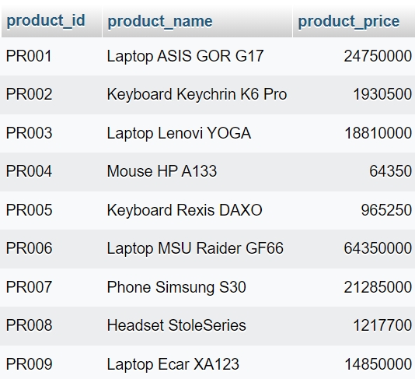

1. Create a view named ‘**StaffWillRetire’** to display **staff_id**, **staff_name**, and **Staff Age** (calculate the age from **staff_dob**) for **every staff with Staff Age more than 50**.

(**CREATE VIEW, SELECT, DATE_FORMAT, FROM_DAYS, DATEDIFF, AS**)

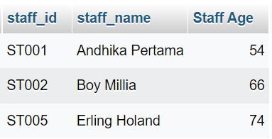

1. Create view named ‘**BestSeller’** to display **product_id, product_name, product_price** for every **product that is sold more than or equals to twice**.

(**CREATE VIEW, SELECT, JOIN, COUNT**)

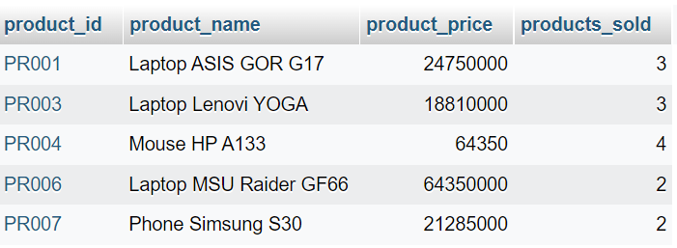

1. Delete data from customers table for every customer that is born after 2002.

(**DELETE, WHERE, YEAR**)

